Name: G.R.Nithishkumar (20ucs088)
Program:
Ex No.: 7

#include<stdio.h>
#include<string.h>
#include<ctype.h>
#include <stdlib.h>
int num(char *temp)
{
int i=0,flag=0;
for(i=0;i<strlen(temp);i++)
{
if(!isdigit(temp[i]))
{
flag=1;
break;
}
}
if(flag == 0)
return 1;
else
return 0;
}

int main()
{
int i=0,j,flag=0,k=0,m=0;
float res;
char read[100],*token,*temp,*a,*b;
char arr[100][100],arr1[100][100];
FILE *fp;
fp = fopen("input.txt","r");
while(fgets(read,100,fp) != NULL) {
token = strtok(read,"=");
temp = strtok(NULL,"=");
temp = strtok(temp,";");
if(strstr(temp,"+")) {
a = strtok(temp,"+");
b = strtok(NULL,"+");
if(num(a) && num(b)) {
res = atoi(a) + atoi(b);
printf("%s=%.2f;\n",token,res);
}
else
printf("%s=%s+%s;\n",token,a,b);
}
else if(strstr(temp,"-")) {
a = strtok(temp,"-");
b = strtok(NULL,"-");
if(num(a) && num(b)) {
res = atoi(a) - atoi(b);
printf("%s=%.2f;\n",token,res);
}
else
printf("%s=%s-%s;\n",token,a,b);
}
else if(strstr(temp,"*")) {
a = strtok(temp,"*");
b = strtok(NULL,"*");
if(num(a) && num(b)) {
res = atoi(a) * atoi(b);
printf("%s=%.2f;\n",token,res);
}
else
printf("%s=%s*%s;\n",token,a,b);
}
else if(strstr(temp,"/")) {
a = strtok(temp,"/");
b = strtok(NULL,"/");
if(num(a) && num(b)) {
res = atoi(a) / atoi(b);
printf("%s=%.2f;\n",token,res);
}
else
printf("%s=%s/%s;\n",token,a,b);
}
else
printf("%s=%s;\n",token,temp);
}
fclose(fp);
return 0;
}

Input file:

a=16*8;
b=76+55;
c=56/4;

Output: Ex7

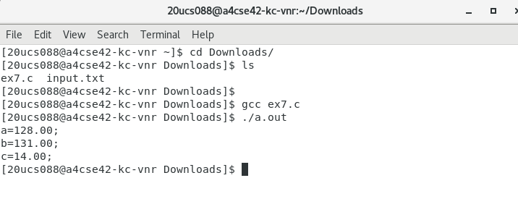

Name: G.R.Nithishkumar (20ucs088)
Program:
Ex No.: 8

#include<stdio.h>
#include<string.h>
#include<ctype.h>
int main()
{
char read[100],*token,*temp,*temp1,*temp2;
FILE *fp;
fp=fopen("input.txt","r");
while(fgets(read,100,fp) !=NULL)
{
token=strtok(read,"=");
temp=strtok(NULL,"=");
if(strstr(temp,"**"))
{
temp=strtok(temp,"**");
temp1=strtok(NULL,"**");
temp2=strtok(temp1,";");
if(!strcmp(temp1,"2"))
{
printf("%s=%s*%s;\n",token,temp,temp);
}
else
{
printf("%s=%s**%s;\n",token,temp,temp2);
}
}
else
{
printf("%s=%s",token,temp);
}
}
fclose(fp);
return 0;
}

Input file:

a=a**2;
u=i;
r=l**2;
v=e;

Output: Ex8

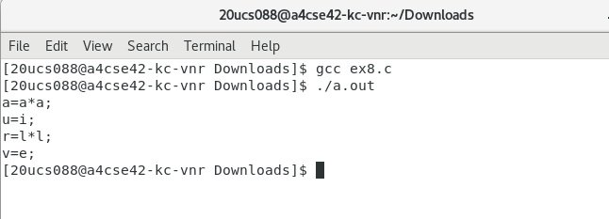

Name: G.R.Nithishkumar (20ucs088)
Program:
Ex No.: 9

#include<stdio.h>
#include<string.h>
#include<ctype.h>
int main()
{
char read[100],*token,*temp,*temp1;
FILE *fp;
fp=fopen("input.txt","r");
while(fgets(read,100,fp) !=NULL)
{
token=strtok(read,"=");
temp=strtok(NULL,"=");
if(strstr(temp,"+"))
{
temp=strtok(temp,"+");
temp1=strtok(NULL,";");
if(!strcmp(temp,token))
{
if(strcmp(temp1,"0"))
printf("%s=%s+%s;\n",token,temp,temp1);
}
else
{
printf("%s=%s+%s;\n",token,temp,temp1);
}
}
else if(strstr(temp,"*"))
{
temp=strtok(temp,"*");
temp1=strtok(NULL,";");
if(!strcmp(temp,token))
{
if(strcmp(temp1,"1"))
printf("%s=%s*%s;\n",token,temp,temp1);
}
else
{
printf("%s=%s*%s;\n",token,temp,temp1);
}
}
else
{
printf("%s=%s",token,temp);
}
}
fclose(fp);
return 0;
}

input file:

c=b+c;
a=a*1;
c=c+0;
d=e+u;

Output: Ex9

